

Dr. APJ ABDUL KALAM SCHOOL OF ENGINEERING
DEPARTMENT OF ENGINEERING

STUDENT NAME: DHEERAJ SURIYA

ROLL NO: 23BTCE116
BRANCH: BTECH IN COMPUTER SCIENCE COURSE: Design Thinking
DATE OF ISSUED: 13/09/ 2026
DATE OF SUBMISSION:20/09/2026
MAX MARKS:
OBTAINED MARKS:

Signature of the Student Signature of the Faculty

LAB - 1 REPORT

Problem Discovery and Need Identification:

Topic: Online food delivery services face frequent delays and wrong orders

Step - 1: Observation

Observation Method
- Observed real-life usage at home + public settings (college canteen / hostel deliveries)
- Observed delivery process through food delivery apps (Swiggy/Zomato style simulation)
- Observed customer reactions during delays and wrong orders

Observation Log (Output: Observation log)
Observation No. | Situation Observed | User Behaviour | Issues Noted | Constraints
1 | User places food order | Frequently checks app tracking | Anxiety increases when delivery time increases | Inaccurate ETA predictions
2 | Order tracking shows “delivery partner assigned” | User refreshes tracking repeatedly | Confusion when order stops moving | Poor GPS / routing
3 | User calls delivery partner | Angry tone, repeated calling | Delivery partner cannot give clear answer | Lack of communication tools
4 | Delivered food is wrong | User checks items only after delivery | Frustration and complaint raised | Sealed packaging makes checking hard
5 | Wrong item missing / extra item | User files complaint | Customer doubts refund fairness | Customer support system delays
6 | Restaurant delay | User sees “preparing your order” too long | User frustration, may cancel | Restaurant workload, limited staff
7 | Delivery partner rushes delivery | User receives spilled food | Emotional dissatisfaction | Time pressure to deliver quickly

Key Observation Notes
- Most users show high stress when ETA changes repeatedly
- Wrong order causes maximum anger because it ruins meal plans
- Delivery partners often appear overloaded
- Restaurant packaging + labelling is inconsistent

Step 2: User Identification

Stakeholder List (Output: Stakeholder list)
 | Stakeholder Group |  | Role | Expectations
 | Customers (end users) |  | Place orders and receive food | Fast delivery, correct items, accurate ETA, quick support
 | Delivery Partners |  | Pick up & deliver orders | Easy navigation, fair delivery time, clear instructions
 | Restaurants |  | Prepare and pack food | Smooth order processing, fewer cancellations, clear order info
 | Customer Support/Admin |  | Handle complaints and refunds | Clear issue details, faster resolution, less fraud
(At least 3 groups covered ✅)

Step 3: Interviews / Surveys

Interview Setup
- Sample size: 30 users
- Participants: 20 customers, 6 delivery partners, 4 restaurant staff
- Method: short structured interview + feedback collection

Open-ended Interview Questions (5–8)
- Describe your last experience with an online food delivery order.
- What problems do you face most often (delay / wrong order / missing items)?
- How do delays affect your mood or daily routine?
- What do you usually do when the order is wrong?
- Do you trust the delivery ETA shown in the app? Why/why not?
- In your opinion, why do wrong orders happen frequently?
- What would improve your delivery experience most?
- Have you ever stopped using delivery apps due to bad experiences?

Interview Summary (Output: Interview summary)

Overall Insight
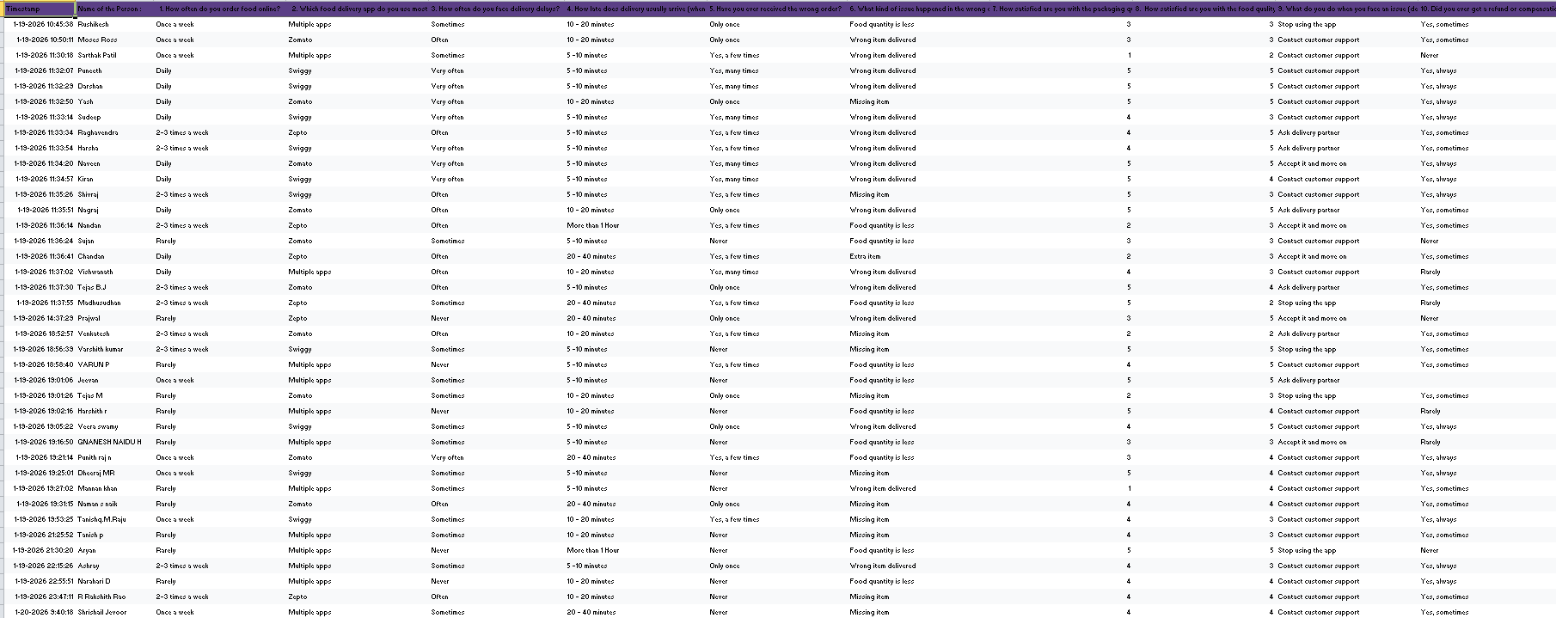

Step 4: Pain-Point Analysis

Pain-Point Table (Output: Pain-point table)
Pain Point | Description | Category
Unpredictable delays | Delivery time keeps extending | Systemic
Wrong items delivered | Food mismatch from order | Functional
Missing items | Side dish not included | Functional
No proactive updates | App doesn’t clearly explain delay reason | Systemic
User frustration & anxiety | Repeated checking, anger | Emotional
Embarrassment/social impact | Late delivery for guests | Emotional
Customer support delays | Slow refund / limited resolution | Systemic
Poor packaging | Spills, damaged items | Functional

Most Critical Pain Point:
Wrong order / missing items
Because it:
- ruins user trust permanently
- causes conflict between customer and service provider
- cannot be compensated by refund fully (hunger + time loss)

Step 5: Root Cause Identification

Selected Critical Pain Point:
Wrong Orders Delivered

Method Used: 5-Why Analysis

Root Cause Diagram (Output: Root cause diagram)
Problem: Customer receives wrong order
- Why did customer receive wrong order?
→ Delivery partner delivered wrong package.
- Why wrong package delivered?
→ multiple orders picked up together; package labelling unclear.
- Why labelling unclear?
→ Restaurants don’t follow consistent tagging system.
- Why restaurant doesn’t follow consistent tagging?
→ High workload during peak time; no time to verify.
- Why verification not done?
→ No enforced quality-check step + system prioritizes speed over accuracy.
Root Causes Identified
- Lack of standardized packaging labels
- No mandatory verification checkpoint
- Peak-hour overload causes human mistakes
- Delivery batching increases confusion
- System design prioritizes speed
Symptoms vs. Root Cause
- Symptom: wrong food received
- Root causes: labelling + verification + workload + batching
Step 6: Wicked Problem Understanding

Why this is difficult
This problem is not simple because:

1) Hard to define clearly
- Delay is not always due to delivery partner.
- Wrong orders may occur at restaurant or during pickup.

2) Multiple stakeholders with conflicting needs
- Customer wants fast + accurate
- Delivery partner wants more orders + less pressure
- Restaurant wants high order volume + minimal cancellation
- Platform wants profit + fast delivery ratings

3) No single solution
- Even if delivery improves, restaurant mistakes still happen.
- Even if restaurants improve, delivery batching still creates confusion.

Classification
Wicked Problem
Because it is:
- multi-stakeholder
- system-based
- requires multiple solutions (process + tech + human training)

Output: Wicked problem explanation
The problem is wicked due to complex interactions between customer expectations, restaurant operations, delivery constraints, and platform algorithms. Fixing one side may worsen another (example: reducing batching improves accuracy but increases delivery cost).

Step 7: Reflection (1 Page)

Reflection (Output: Reflection)
During this lab, I initially assumed that delivery delays and wrong orders happen mostly because delivery partners are careless or slow. However, after observation and interviewing stakeholders, I realized that the issue is much deeper and system-driven. Many delivery partners are working under high pressure with multiple orders assigned, while restaurants face peak-hour overload, causing mistakes in packaging and labeling.
One incorrect assumption was believing that ETA delay is always intentional or due to lazy service. Instead, the ETA changes due to multiple system constraints like traffic, restaurant preparation time, and assignment algorithms. Another assumption was that refunds solve dissatisfaction, but most users stated that refund only solves money loss, not hunger and time loss.
User perspectives strongly changed my understanding. Customers focus on emotional damage—anger, frustration, embarrassment—while delivery partners highlight workload and lack of control over restaurant delays. Restaurant staff admitted that mistakes happen due to speed pressure and lack of final checking.
This lab taught me why jumping directly to solutions is risky. If we assume the wrong cause, we create wrong solutions. For example, blaming delivery partners alone could lead to stricter penalties, but that would reduce motivation and worsen service quality. Real solutions require understanding root causes and stakeholder conflicts.
Through this lab, I developed skills in observation, stakeholder mapping, interview design, pain-point categorization, and root cause analysis (5-Why). I also learned how complex real-world problems require empathy and systems thinking before proposing improvements.

